How to run cucumber runner file using Maven POM XML file.
- Enter below code in maven POM file above </Project> tag.

Note:
- Update java jdk path under executable (Orange colour) as per jdk location in your system.
- Update java runner java file path under yellow marked line as per java file location.
<build>
<plugins>
<plugin>
<groupId>org.apache.maven.plugins</groupId>
<artifactId>maven-compiler-plugin</artifactId>
<version>3.7.0</version>
<configuration>
<source>1.8</source>
<target>1.8</target>
<fork>true</fork>
<executable>C:\Program Files\Java\jdk1.8.0_162\bin\javac</executable>
</configuration>
</plugin>
<plugin>
<groupId>org.apache.maven.plugins</groupId>
<artifactId>maven-surefire-plugin</artifactId>
<version>2.21.0</version>
<configuration>
<includes>
<include>**/Fleet_ActivityManagement_LoadedFileStepStatus_RUN.java</include>
</includes>
</configuration>
</plugin>
</plugins>
</build>

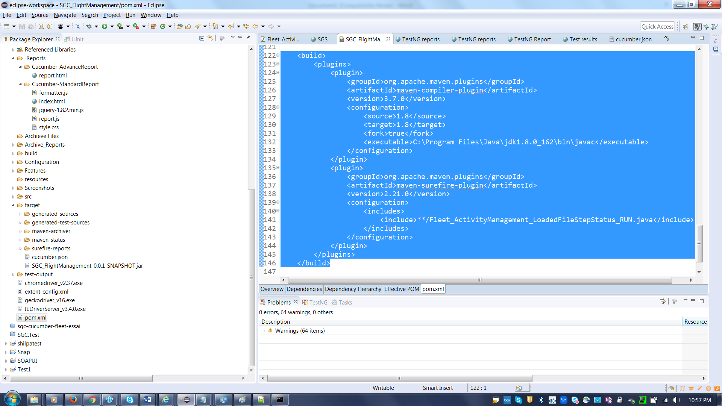

- Select pom.xml file and then do right click and perform “Run As→ Maven clean”
- Again “Run As→ Maven Install”

